SHAIK BADEMIYA |  | 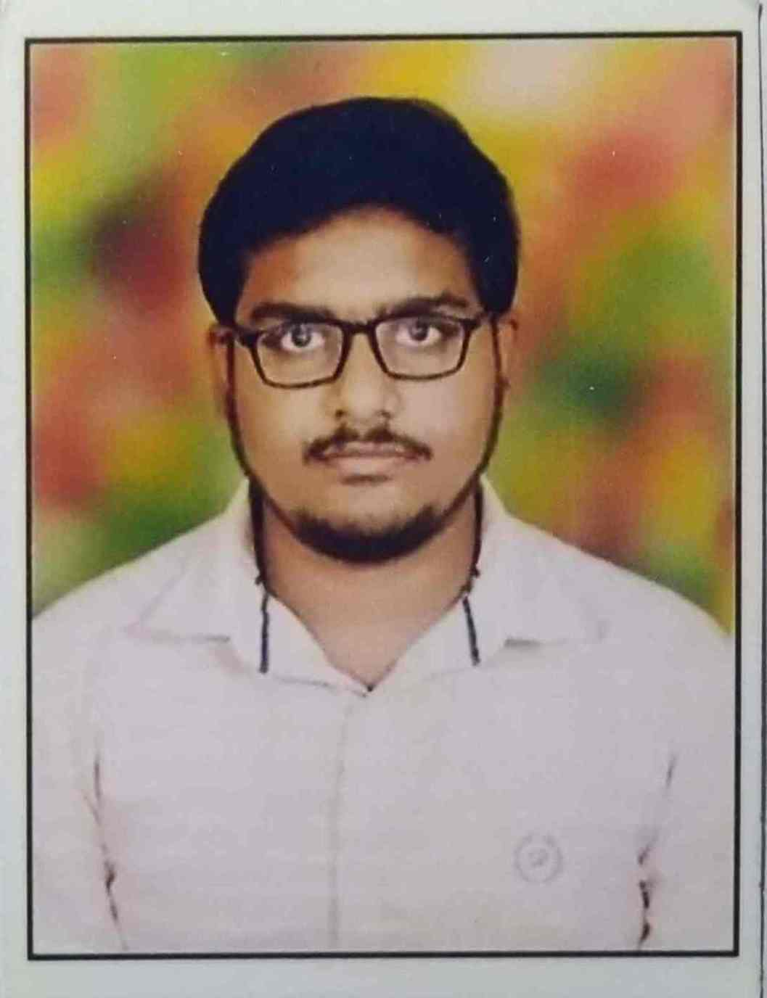
Email | : 300bademiya@gmail.com
Phone No | : +91 9010632861
LinkedIn | : https://www.linkedin.com/in/shaik-bademiya-140028182
HackerRank | : https://www.hackerrank.com/300bademiya
CAREER OBJECTIVE
Would like to be a part of a reputed organisation by securing a responsible and challenging career opportunity, fully utilize my trainings and skills, while making a significant contribution to the success of the company and to achieve my professional goals.
ACADEMIC QUALIFICATIONS
Qualification | College/ School | University/ Board | Year of Passing | Percentage/ CGPA
B.Tech  (ECE) | Lakireddy Bali Reddy College of Engineering (Autonomous) | JNTU Kakinada, AP | 2022 | 9.0/ 10
Intermediate | Hyderabad Institute of Excellence Junior College | BIE, TS | 2018 | 95.6%
SSC | Sri Bhaskara Memorial High School | SSC, TS | 2016 | 9.3/ 10
PROJECTS
- EEG Signal Analysis for Human Stress Monitoring by using Laboratory for Virtual Instrumentation Engineering Workbench (LabVIEW).
- Water level indicator, sound detector, etc by using the hardware electronic components.
- Bluetooth controlled car by using Bluetooth module with Arduino.
- Smart Door Lock System by using 8051 microcontroller.
- Image processing using MATLab.
- Done projects like traffic control, temp control, using LabVIEW by National Instruments.
TECHINICAL SKILLS
Programming languages | : C, Python, Java
DB Query Languages | : SQL
HDL’s | : VHDL, Verilog
Tools | : Vivado, Mentor Graphics
Packages | : AutoCAD, MATLab, LabView
Cloud | : Amazon AWS
CERTIFICATIONS
- Certified with AWS Solution Architect Associate Certification.
- Completed a 12 week NPTEL course on Joy of Computing using Python with a consolidated score of 83% and stood in category of elite.
- CCNA certification from Cisco.
- Got certified by various platforms like Sololearn, Udemy, Coursera, Internshala.
- Got certificates in the programming languages from HackerRank.
- Got certified in the Code Riders Event by Cisco.
INTERNSHIP
- Successfully completed the internship and got certified on the Certified Ethical Hacking (CEH) course which was organized by the Internshala.
- Completed intern role as a Cyber Security Intern from the Cisco Networking Academy.

Achievements
- Got certified in various events like Cruize, Crib and Project presentation which were conducted in the LAKSHYA event.
- Winners of kabaddi in School Level Competition.
- Got district school and mandal level winner in Chekumuki Science Talent Test.
- Won cash prize for being punctual to the college.
- Got selected in the test conducted by HIE, Vikarabad.
Academic
- Participated in the Chekumuki Science Talent Test in the school, mandal and district levels.
- Got appreciation from the teachers for supporting my friends in different.
- One of the topper in the class at school and college level.
Co-Curricular
- Participated in a three week online training on Python programming, IoT, Embedded Systems conducted by APSSDC.
- Active student member of the ISTE.
- Participated in the PCB designing workshop conducted in LBRCE.
- Participated in the Sixth Sense Robotics workshop conducted in JNTUK.
- Participated in technical events like Cruize, Crib, Project presentation during the college fest, LAKSHYA.
Extra-curricular
- School team kabaddi player.
- Served as class representative (CR) in intermediate, serving in B-Tech too.
- Organized different events in the college fest, LAKSHYA.
- Completed 1 month Yoga training course.
Strengths
- Leadership skills.
- Self motivated.
- Multitasking.
- Analytical thinking.
- Presentation skills.
- Accepting challenges.
- Openness to Feedback.
Hobbies
- Gaining knowledge on new things.
- Solving puzzles like Rubik’s cube, Sudoku.
- Playing Badminton.
Personal details
DOB | : 23/05/2001
Gender | : Male
Father’s name | : Shaik Peda Dada Saheb
Languages known | : English, Hindi, Urdu, Telugu
Declaration
I do hereby declare that the above particulars of facts and information stated are true, correct and complete to the best of my belief and knowledge.

Date: 01-11-2022
Place: Meenavolu Shaik Bademiya

